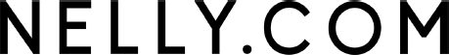

POWER OF ATTORNEY

Proxy form supplied by the company in accordance with Chapter 7, Section 54 a of the Swedish Companies Act. Shareholders who wish to be represented by proxy can use this proxy form.
The undersigned shareholder in Nelly Group AB (publ) ("Nelly") hereby authorises

Proxy holder's name |  | Daytime phone number
Address |  | Postcode and city

to vote and postal vote for all of the shares owned by the shareholder in Nelly at the Annual General Meeting on Monday 18 May 2026.

Place and date |  | Authorised signature of shareholder
Name of the shareholder |  | Clarification of signature
Personal identification no. or company reg. no. of the shareholder |  | Daytime phone number

Processing of personal data
For information regarding the processing of your personal data, please refer to: www.computershare.com/se/gm-gdpr and www.euroclear.com/dam/ESw/Legal/Privacy-notice-bolagsstammor-engelska.pdf.

